Condition Adjunct

✅ What Is a Condition Adjunct?
# Source: AI Source: Provided by: [Data Path: Persons Table -> ID Column: 1, Name_En Column: Motasem Essam] -> From: [Chatgpt (GPT-4-turbo)] on [8/6/2025]
A condition adjunct is a word, phrase, or clause that states the condition under which the action of the main clause would happen. It tells in what situation something is true or could occur.
It answers the question:
- Under what condition?

🔸 Common Forms of Condition Adjuncts:
# Source: AI Source: Provided by: [Data Path: Persons Table -> ID Column: 1, Name_En Column: Motasem Essam] -> From: [Chatgpt (GPT-4-turbo)] on [8/6/2025]
- Subordinate Clauses: if, unless, provided that, in case, as long as, even if
- Prepositional Phrases: under certain conditions, in the event of, on condition of

🔸 Examples of Condition Adjuncts in Sentences:
# Source: AI Source: Provided by: [Data Path: Persons Table -> ID Column: 1, Name_En Column: Motasem Essam] -> From: [Chatgpt (GPT-4-turbo)] on [8/6/2025]
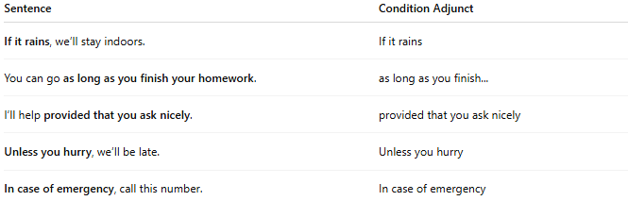
Sentence | Condition Adjunct
If it rains, we’ll stay indoors. | If it rains
You can go as long as you finish your homework. | as long as you finish...
I’ll help provided that you ask nicely. | provided that you ask nicely
Unless you hurry, we’ll be late. | Unless you hurry
In case of emergency, call this number. | In case of emergency

🔸 Position in the Sentence:
# Source: AI Source: Provided by: [Data Path: Persons Table -> ID Column: 1, Name_En Column: Motasem Essam] -> From: [Chatgpt (GPT-4-turbo)] on [8/6/2025]
- Initial: If you study hard, you will pass.
- Final: You will pass if you study hard.

🔸 Reminder:
# Source: AI Source: Provided by: [Data Path: Persons Table -> ID Column: 1, Name_En Column: Motasem Essam] -> From: [Chatgpt (GPT-4-turbo)] on [8/6/2025]
A condition adjunct is not grammatically required, but it frames the action of the sentence within a specific scenario.
🟢 "We’ll stay indoors."
🟡 "If it rains, we’ll stay indoors." → Condition adjunct adds situation

